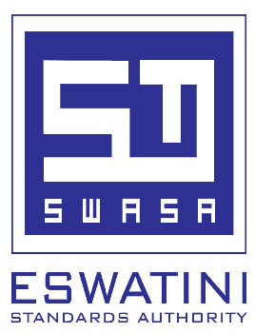 

**WP 16 (A) PUBLIC REVIEW STAGE NOTICE**

This notice serves to inform the public that the following **Draft Eswatini National Standard** (**SZNS**) is now available for commenting. The draft Standard as well as the comment form will be available at Eswatini Standards Authority (SWASA) Information Office upon request through walk in, phone and via email. The draft standard can also be found on Eswatini Horticulture Information Systems at [**https://www.ehis.co.sz/**](https://www.ehis.co.sz/)

1. **PRD/SZNS 081** Local Global Good Agricultural Practices (GAP) for horticultural crops.

The circulation of the draft Standard started on **1th of September** and will end on the **30th of October 2024.**

From **1st to 4th October**, SWASA, in collaboration with NAMBoard, will be conducting national public consultations across the four regions. The venues for these consultations will be confirmed soon. This exercise seeks to get the public to comment on the draft Standard before it is declared as Eswatini National Standard.

The comments should indicate the clause, table, paragraph and suggested alteration. All comments may be submitted to **Information Officer** or emailed to the details below:

**The Technical Manager**

**Eswatini Standards Authority**

**P.O. Box 1399, Matsapha**

**Tel: (+268) 2518 4633**

**Email:** [**pmndawe@swasa.co.sz**](mailto:pmndawe@swasa.co.sz) **or** [**info@swasa.co.sz**](mailto:info@swasa.co.sz)